TU Dublin City Campus
TU059/TU060/TU256 + PhD
_________________________________________________
Week 2 Practical MATH9102
Getting familiar with basic statistics and plots in R
_____________________________________________________
SETUP You can use this time to setup R Studio on your own laptop if you haven’t already done so.
RESOURCES:
- Tidyverse cheatsheat - https://www.datacamp.com/cheat-sheet/tidyverse-cheat-sheet-for-beginners
- R Studio ggplot2 Cheatsheet -https://rstudio.github.io/cheatsheets/html/data-visualization.html
- The complete ggplot2 Tutorial - http://r-statistics.co/Complete-Ggplot2-Tutorial-Part1-With-R-Code.html
Prelim. Review the tidyverse cheatsheet (tidyverse is a collection of R packages that you can use to transform and visualize data) – we installed it last week so you should be able to use it using the library command this week.
Step 1:
- Navigate to the sub-folder R Code + Data of the W2 folder.
- Download the following data files to a location where you can easily locate them:
  - FacebookNarcissim.dat
  - RomCom-UrbanRural.dat
  - Festival-UrbanRural.dat
  - survey.dat
  - experim.dat
- Download all the .qmd files.
Step 2. Launch R Studio. Open and step through each file and run through the plots created. Render each of the files and make sure you can locate the html output.
- MATH9102-W2-basics-of-plots.rmd
  - This covers the basics of using ggplot
- MATH9102-W2-bar-charts.rmd
  - This covers using ggplot to create basic bar charts
- MATH9102-histograms.rmd
  - This covers using ggplot to create histograms and density plots

Step 4. You will be using the file experim.dat.
This dataset is from the SPSS Survival Guide by Julie Pallant (http://spss.allenandunwin.com.s3-website-ap-southeast-2.amazonaws.com/data-files.html) – a manufactured data set. The dataset refers to a fictitious study that involves testing the impact of two different types of interventions in helping students cope with their anxiety concerning a forthcoming statistics course. Students were divided into two equal groups and asked to complete a number of scales (Time 1). These included a Fear of Statistics test, Confidence in Coping with Statistics scale and Depression scale. One group (Group 1) was given a number of sessions designed to improve mathematical skills, the second group (Group 2) was subjected to a program designed to build confidence in the ability to cope with statistics. After the program (Time 2) they were again asked to complete the same scales that they completed before the program. They were also followed up three months later (Time 3). Their performance on a statistics exam was also measured. The dataset was created using SPSS and has been saved as a .dat file.
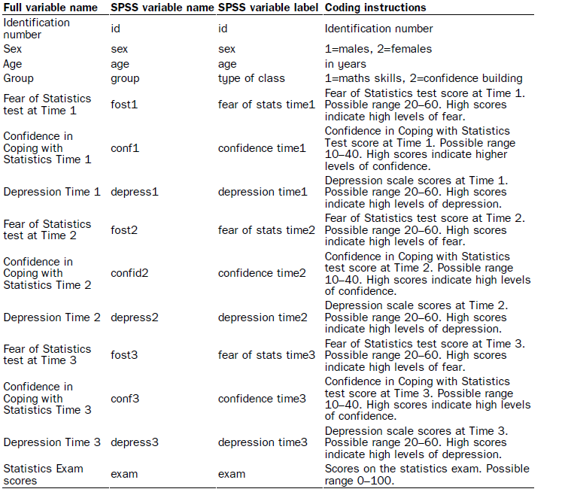
Create your own R markdown to achieve the following using the dataset experim.dat:
- Histograms
  - Build two separate histograms one for fear of statistics scores at time 1 and a second for fear of statistics time 2 (fost1, fost2).
- Barcharts
  - Create bar charts for fear of statistics at time 1 and time 2 by gender.
- Stem and Leaf
  - Create stem and leaf plots for confidence scores at time 1 and time 2 (conf1 and confid2).
- Boxplots
  - Create boxplots for depression at time 1 and time 2 (depress1 and depress2)
  - Create boxplots for depression at time 1 and time 2 by gender.
- Density plots
  - Create density plots for fear of statistics scores at time 1 and time 2.
  - Create density plots for fear of statistics scores at time 1 and time 2 by gender.
  - Statistics exam results (exam).

